Jared Morell

ECE 570.S – Software GPS Receiver

Homework 11

This program computes the relative correlation of the peak power loss between CA codes with and without a navigation data bit transition occurring in the middle of the period. Because the Doppler frequency was assumed to be zero, 1 ms of data was taken so that a full CA code period would be observed. Two CA codes from the same satellite were sampled. One was left the same as the reference signal; the other had the second half of its samples flipped to simulate a navigation data bit transition. Circular correlation was then computed for the cross-correlation of the two CA codes and the auto-correlation of the CA code without a navigation data bit transition. The plots of the correlations can be seen below.

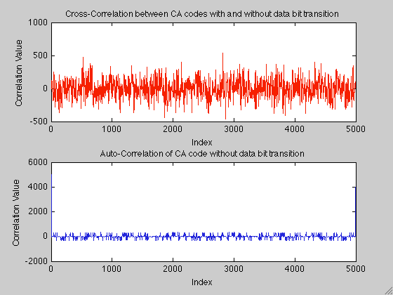

Next, the maximum Doppler frequencies were calculated for the L1 and L5 carrier and the L2C and L5 code using the following formula:

$$f_{d}=f*\frac{v_{LOS}}{c}$$

where $f_{d}$ is the Doppler frequency of *f*, *c* is the speed of light, and $v_{LOS}$ is the line-of-sight velocity between the user and the satellite. The results showed that the max Doppler frequency for the L1 carrier is 4.8872 kHz, for the L5 carrier is 3.6495 kHz, for the L2C code is 3.1735 Hz, and for the L5 code is 31.7350 Hz.

Finally, the time required (in ms) to misalign L2C and L5 codes by ½ chip was calculated using the following formula:

$$n=\frac{f_{code}}{{2*f}_{d_code}*1023}$$

The time required for both the L2C and L5 codes was 158 ms.